WHO Health Dashboard – Data Analysis Report
Project: WHO Health Pipeline
Author: Joao
Date: May 2025

1. Dataset Description
The dataset was extracted from the WHO Global Health Observatory API and includes indicators related to health coverage and essential services across countries. The cleaned and processed data includes the following key indicators:
- Life Expectancy (life_expectancy): Life expectancy at birth, disaggregated by sex, with high/low confidence bounds.
- Universal Health Coverage Index (uhc_index): Composite index measuring access to essential health services (scale: 0–100).
- Access to Safe Drinking Water (water_access): Percentage of population with access to safely managed drinking water, disaggregated by area of residence (urban, rural, total).
- Access to Safe Sanitation Services (sanitation_access): Percentage of population with access to safely managed sanitation, also by area of residence.
All indicators are linked using a shared key: pk_country_year (combination of ISO-3 country code and year).

2. Visual Insights and Observed Patterns

A. Life Expectancy
- Global Trend: Life expectancy has steadily increased from 2000 to 2019 in most countries, with exceptions in regions affected by conflict or health crises.
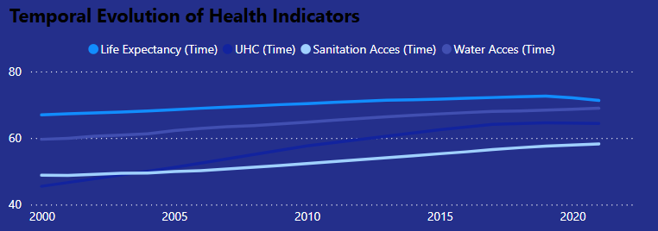
- Gender Gap: Female life expectancy is consistently higher than male across all countries, with an average global difference of ~5.

  - Male :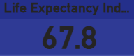
  - Female: 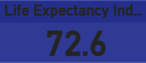

- Data Gaps: Some countries show missing values.
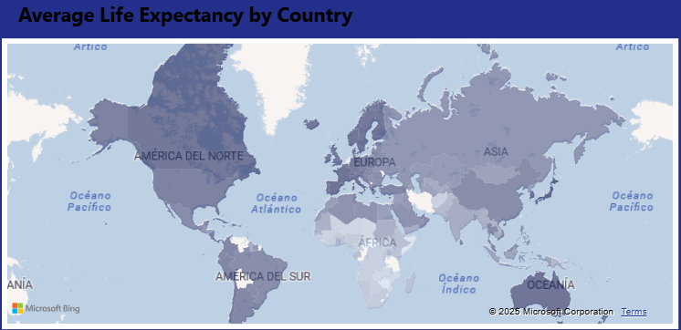

B. Universal Health Coverage Index (UHC)
- Definition: The UHC index measures access to essential health services including reproductive, maternal, newborn, child health, infectious diseases, noncommunicable diseases, and service capacity.
- Observations:
  - Top-performing countries (e.g., Japan, Norway, Sweden) score above 80.
  - Sub-Saharan Africa and Southeast Asia tend to score below 50, indicating major gaps.
  - There is a positive correlation between UHC and life expectancy (r ≈ 0.85).
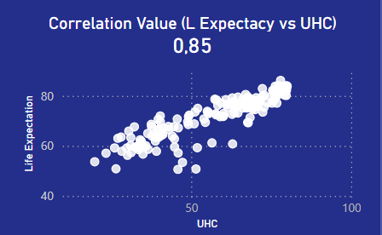

C. Access to Safe Drinking Water
- Urban-Rural Divide: Urban areas consistently report higher access rates, often exceeding 95%, while rural access shows more variability.
- Coverage Leaders: High-income countries report nearly universal coverage across all residence types.
- Data Issues: In some cases, total population coverage is missing, but urban and rural values are present; we applied interpolation where both were available.
- Correlation: Life expectancy correlates positively with access to safe drinking water (r ≈ 0.71).
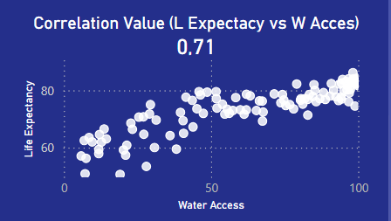

D. Access to Sanitation Services
- Progress and Gaps:
  - Sanitation progress has lagged behind water access globally.
  - In rural areas of Sub-Saharan Africa, access often remains below 30%.
- Urban-Rural Disparities: The urban-rural gap is more pronounced for sanitation than for water.
- Correlation: Access to sanitation is strongly associated with life expectancy (r ≈ 0.84).
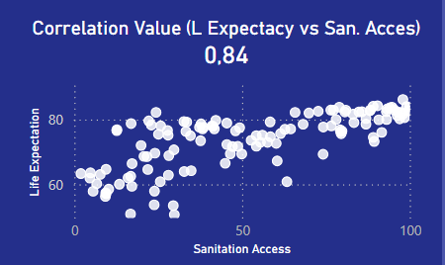

3. Data Limitations and Considerations
- Missing Values: Some countries have no total values but do report urban and rural components (or not report one of these).
- Dimensional Inconsistency: Certain indicators lack data for overlapping years, which limits synchronized multi-variable analysis.
- Interpolation Methodology: Total values were estimated conservatively only when both urban and rural values were present.
- Bias Risk: Countries with lower infrastructure are more likely to have missing or incomplete records, which may affect correlation accuracy.

4. Recommendations

A. Pipeline Improvements
- Add a data validation step post-transformation to detect outliers and anomalies.
- Compute and include regional averages (e.g., WHO regions) to enable better benchmarking.
- Automate total value calculation from urban and rural values when both are available.

B. Power BI Dashboard Enhancements
- Add a "Data Quality" page showing missing value ratios by indicator and country.
- Implement dynamic filters for income level and WHO region.
- Add trend visuals using rolling averages and year-over-year deltas.

5. Conclusions
This analysis supports the hypothesis that life expectancy is positively associated with health system strength (UHC), access to clean water, and access to sanitation. The WHO Health Dashboard offers a strong foundation to explore global health disparities and monitor progress toward Sustainable Development Goals (SDGs).
With more robust data handling and contextual filters, the dashboard can become a powerful tool for policymakers, NGOs, and researchers in global health.

